Student Name: Xianglong Lin Student Number: 45791439 Team Name: H2OMG
Week: _11_
Title: EJS Dynamic Front-End Page, GitHub Desktop Code Sharing, Privacy and Security Considerations
Description:
In the 11th week, the main task was to prepare for the upcoming Exhibit 2. I took the initiative to receive the task of front-end coding (EJS) for the "Home" and "Setting" pages of the water resource protection system. GitHub Desktop is used to share and synchronise front-end code, allowing other front-end team members to clearly see code differences and comments through automatic highlights. Although some team members using Windows systems had some connection issues when configuring local to GitHub due to a lack of experience, fortunately, I had practice in another DECO course this semester that helped solve the problem smoothly. In addition, I urged all dynamic pages to be created and integrated as soon as possible, preferably by the end of this week. This is to allow at least 1 week for the integration of front-end and back-end (Java) and the connection to the SQL user account database, and to allow for systematic user testing of the entire web-based application before Exhibit 2. A special point I mentioned was that after completing the coding, it would be also important to consider potential code privacy and data security issues, such as how to encrypt the user water flow data from the sensor in a Text file.
Visual Evidence:
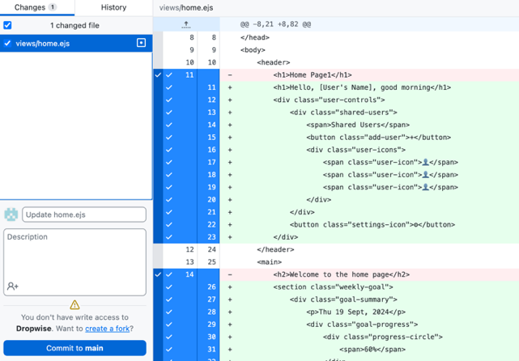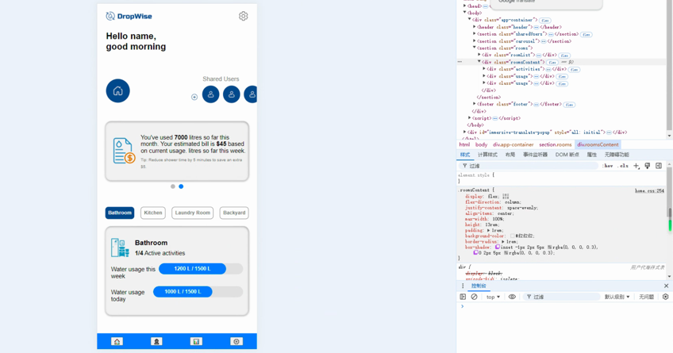
Statement on Learning:
This week's studio work has given me a deeper understanding of front-end code development, which also involves team collaboration, code version management, and control over the overall progress of the project. Although EJS is a JavaScript language that I have never worked with before, being responsible for the "Home" and "Setting" pages has given me an understanding of a new lightweight dynamic web page building language, rather than staying with Java and PHP. I have also experienced the efficiency of GitHub Desktop in team code development and version control.
In addition, my promotion of dynamic page development has allowed me to reserve time for the backend and database, which has made me realise the absolute importance of time management in leading a successful project. Only in this way can we fully understand and consider potential data privacy and security issues contained in the code. This is also a key point mentioned in every DECO course. Therefore, I have now developed the habit of always thinking about privacy and security when coding.

